Receiving Your W-2 Electronically

Employees of G&A Partners’ clients may choose to receive their W-2 electronically via WorkSight instead of receiving a copy via mail.

Benefits of receiving your W-2 electronically:
- Earlier access to your W-2. Electronic Forms W-2 will be available for download on or before January 31, 2022, while paper Forms W-2 are not required to be mailed until January 31, 2022, and may take a couple of weeks for delivery.
- Electronic Forms W-2 offer more security. Because they are mailed, there is the possibility that paper Forms W-2 might be lost, stolen, delayed, or misplaced by the delivery service or upon arrival. Electronic Forms W-2, on the other hand, are stored in the same easy-to-use, secure, and password-protected platform that you already use to access their paystubs and other payroll information, even if you are away from your home/residence.
- Electronic Forms W-2 offer more convenience. Many online tax preparation programs offer the ability to import a copy or photo of your W-2. Electronic Forms W-2 make it easier than ever to take advantage of this option.

How to register to receive your W-2 electronically:
You can register to receive your W-2 electronically using WorkSight, G&A Partners’ online self-service portal.

For your 2021 W-2 to be available electronically on or before January 31, 2022, you must complete the electronic W-2 registration process before December 31, 2021.

IMPORTANT: If you have previously registered to receive your W-2 electronically, you do not need to register again as the election to receive your W-2 electronically remains in force until you revoke it. If you no longer wish to receive your W-2 electronically, you must submit a request in writing to accesshr@gnapartners.com.

To register to receive your W-2 electronically, follow the instructions below:

- Visit http://www.gnapartners.com/login and click the “WorkSight 2.0 Login” button.
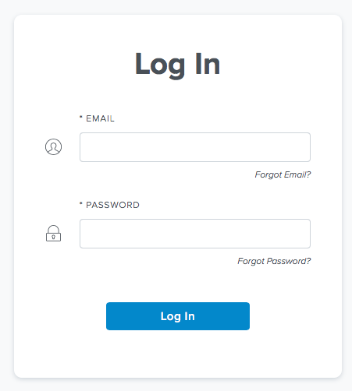
- Enter your username and password and click “Log In.”
The email address you used to create your WorkSight account is your username. If you don’t remember which email address you used, you will need to contact AccessHR at 1-866-497-4222 or accesshr@gnapartners.com for assistance recovering your email address.
If you have forgotten your password, click “Forgot Password?” on the log in screen and follow the prompts on the next screen to reset your password.

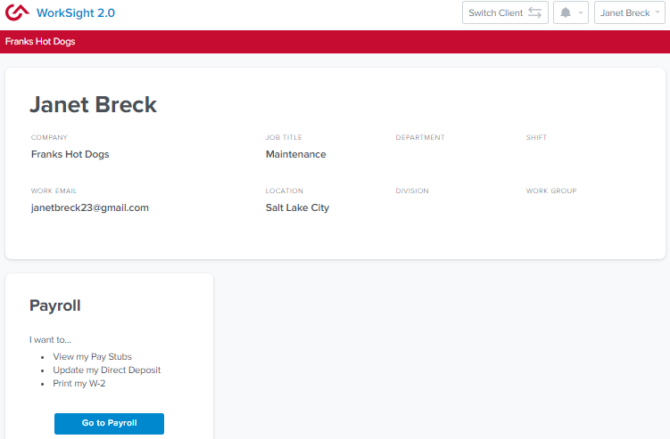
- Once you have logged in, click the “Go to Payroll” button in the “Payroll” widget on the WorkSight home screen. You will then automatically be logged into G&A Partners’ payroll system (Prism).
- Click “Taxes” in the left menu of the dashboard, then click “W-2.”
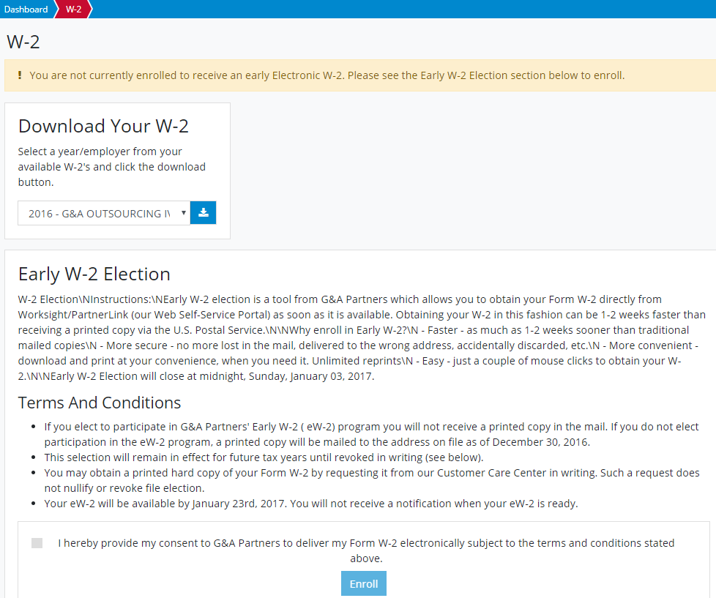
- You will see a yellow box toward the top of the “W-2” screen informing you that you are not currently registered for the eW-2 program (as shown below). Scroll down to the “Early W-2 Election” section at the bottom of the screen, check the box giving G&A Partners consent to deliver your W-2 electronically, and then click “Enroll.”

You are now registered to receive your W-2 statement electronically!

Your request to receive your W-2 electronically instead of via mail will remain in force until you revoke it. If you no longer wish to receive your W-2 electronically, you must submit a request in writing to accesshr@gnapartners.com.

How to access your W-2 electronically:
2021 Forms W-2 will be available in WorkSight by January 31, 2022, for all employees who completed the electronic W-2 registration process before December 31, 2021.

To download your electronic W-2, follow the instructions below:

- Log into WorkSight just like steps 1 and 2 in the “How to register to receive your W-2 electronically” section above.
For help retrieving your username or password, please contact our AccessHR team at 1-866-497-4222 or accesshr@gnapartners.com.

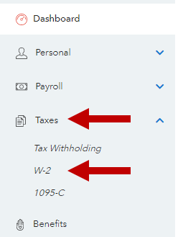
- Go to the Taxes section on the left side of the screen and then click W-2.

- To download a copy of your W-2 statement, choose the year that corresponds to the W-2 you are trying to access (usually the most recent previous calendar year) and click the download icon.

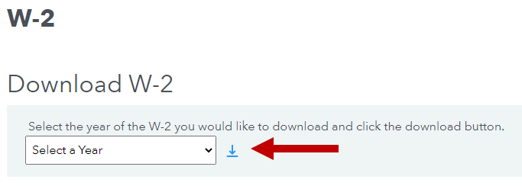
- A PDF file titled “W2” should immediately begin to download to your computer.

