Receiving Your W-2 Electronically

Employees of G&A Partners clients may choose to receive their W-2 electronically via Prism instead of receiving a copy via mail.

Benefits of receiving your W-2 electronically:
- Earlier access to your W-2. Electronic Forms W-2 will be available for download on or before January 31 of each year, while paper Forms W-2 are not required to be mailed until January 31, and may take a couple of weeks for delivery.
- Electronic Forms W-2 offer more security. Because they are mailed, there is the possibility that paper Forms W-2 might be lost, stolen, delayed, or misplaced by the delivery service or upon arrival. Electronic Forms W-2, on the other hand, are stored in the same easy-to-use, secure, and password-protected platform that you already use to access your paystubs and other payroll information, even if you are away from your home/residence.
- Electronic Forms W-2 offer more convenience. Many online tax preparation programs offer the ability to import a copy or photo of your W-2. Electronic Forms W-2 make it easier than ever to take advantage of this option.

How to register to receive your W-2 electronically:
You can register to receive your W-2 electronically using Prism, G&A Partners’ online payroll portal.

In order for your 2021 W-2 to be available electronically on or before January 31, 2022, you must complete the electronic W-2 registration process before December 31, 2021.

IMPORTANT: If you have previously registered to receive your W-2 electronically, you do not need to register again as the election to receive your W-2 electronically remains in force until you revoke it. If you no longer wish to receive your W-2 electronically, you must submit a request in writing to accesshr@gnapartners.com.

To register to receive your W-2 electronically, follow the instructions below:

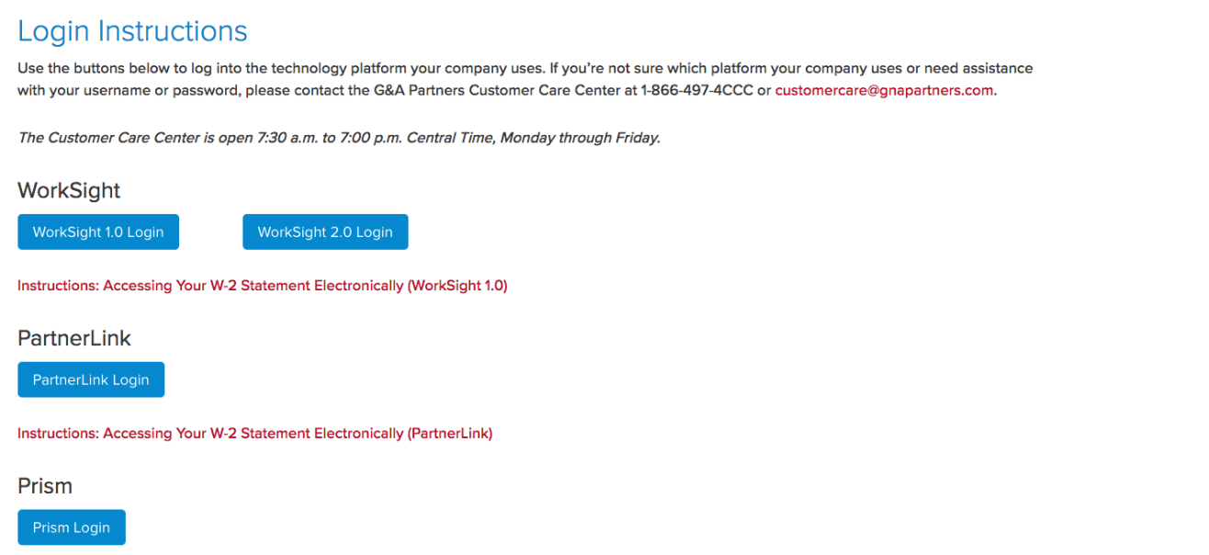
- Visit http://www.gnapartners.com/login and click the “Prism Login” button.
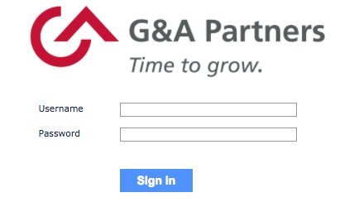
- Enter your username and password and click “Sign In.”
For help retrieving your username or password, contact our AccessHR at 1-866-497-4222 or accesshr@gnapartners.com.

- Click “Taxes” in the left menu of the dashboard, then click “W-2.”
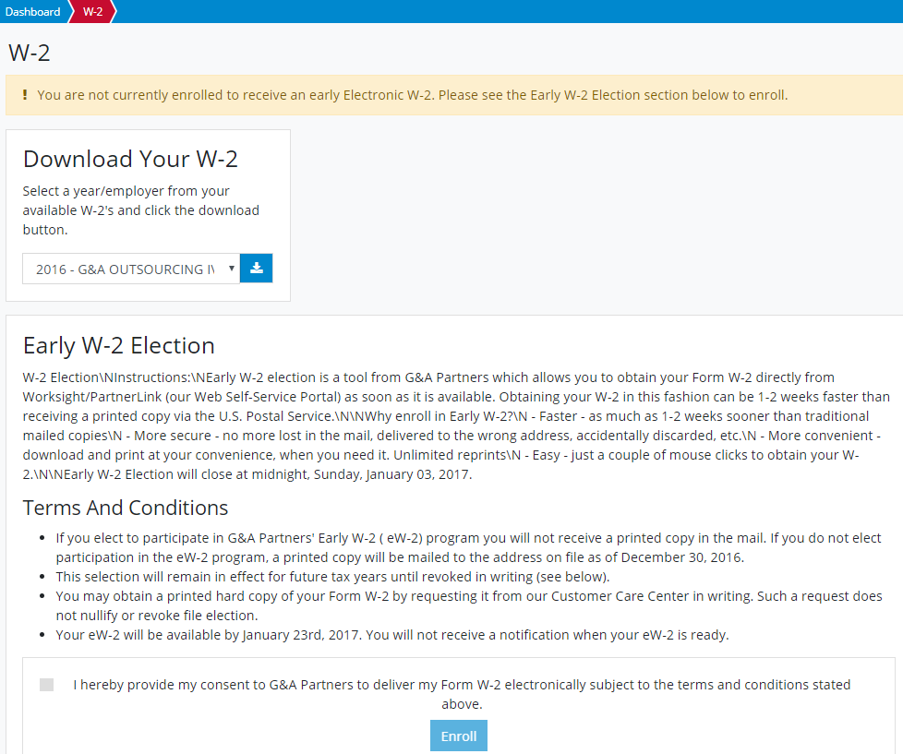
- You will see a yellow box toward the top of the “W-2” screen informing you that you are not currently registered for the eW-2 program (as shown below). Scroll down to the “Early W-2 Election” section at the bottom of the screen, check the box giving G&A Partners consent to deliver your W-2 electronically, and then click “Enroll.”

You are now registered to receive your W-2 statement electronically!

Your request to receive your W-2 electronically instead of via mail will remain in force until you revoke it. If you no longer wish to receive your W-2 electronically, you must submit a request in writing to accesshr@gnapartners.com.

How to access your W-2 electronically:
2021 Forms W-2 will be available in Prism by January 31, 2022, for all employees who completed the electronic W-2 registration process before December 31, 2021.

To download your electronic W-2, follow the instructions below:

- Follow the same steps provided in the “How to register to receive your W-2 electronically” section of this document to log into Prism and access the “W-2” menu in the dashboard.
For assistance in retrieving your username or password, please contact AccessHR at 1-866-497-4222 or accesshr@gnapartners.com.

- You will now see a red box toward the top of the “W-2” screen informing you that you have already signed up for the electronic W-2 (eW-2) program. To download a copy of your W-2 statement, choose the year that corresponds to the W-2 you are trying to access (usually the most recent previous calendar year) and click the download icon.
- A PDF file titled “W2” should immediately begin to download to your computer.

